Imitation Programme
BC AGM 2017

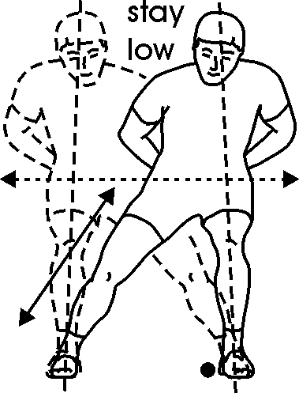 | Side to side :  Both feet are parallel.  Straight feet and knee  Stay always under 90 degrees |  | 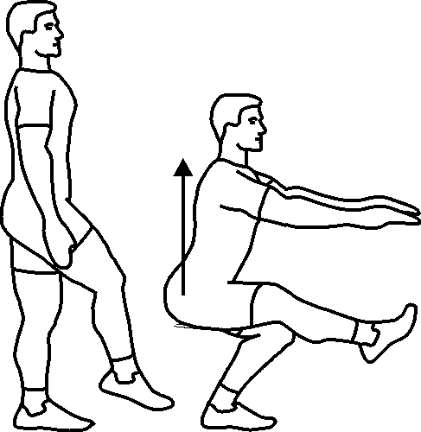 | Squat 1 leg xover alternate:  Always on 1 leg  Down on right + x over  Switch to left at the bottom  Up on left  Alternate: Down Left/Up Right
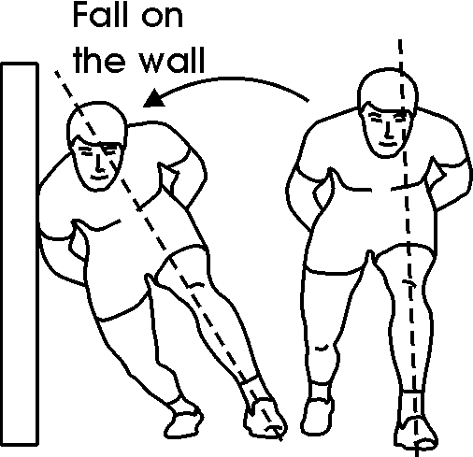 | Push left leg:  Stabilization  Knees together (R higher)  Falling on side & Push  Reception & Repeat |  | 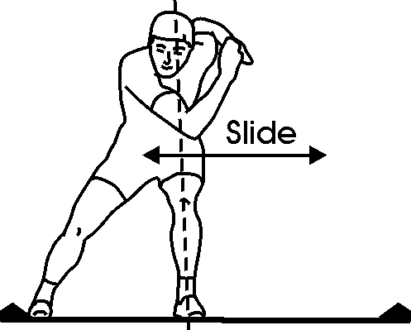 | Side to Side : Full recovery  No Slide board  Always on 1 leg  Knees together  Falling on the side  Reception & recovery with free leg
 | Push right leg:  Stabilization  Knees together (L higher)  Falling on side & Push  Reception & Repeat |  | 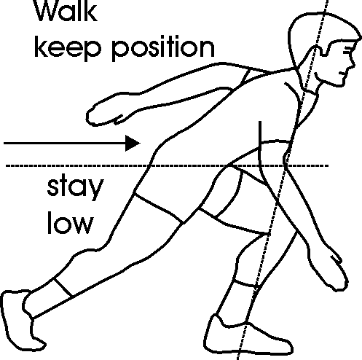 | Low walk:  Basic SS position  Front leg at 80.  Back leg, knee is close to ground  ‘’Walking’’ at the same tempo
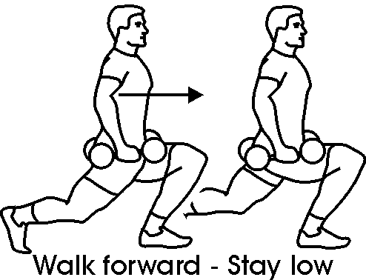 | German Walk :  Both hand behind the head  Upper body straight  Front leg always at 90.  Straight feet & knee  No extra weight |  |  | Side to Side Jump :  Always on 1 leg  Knees together  Falling on the side + push/jump  Reception on 1 leg
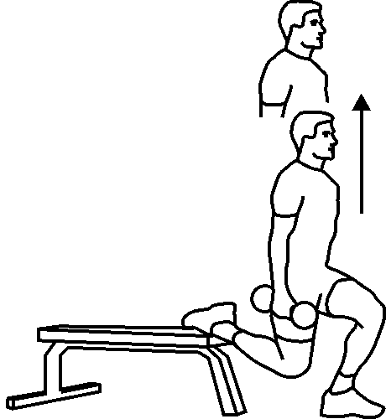 | Squat 1 leg (half L/half R)  Upper body straight  Straight feet & knee  Hips parallel  No extra weight |  | 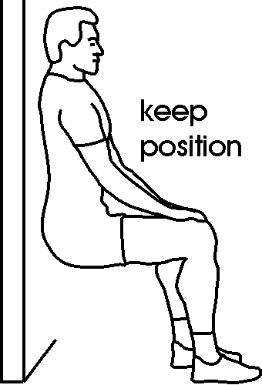 | Basic position baby steps :  Upper body slightly incline 45  No upper body movement  Straight feet & knee  No extra weight  Lift up 1 feet at the time, alternate
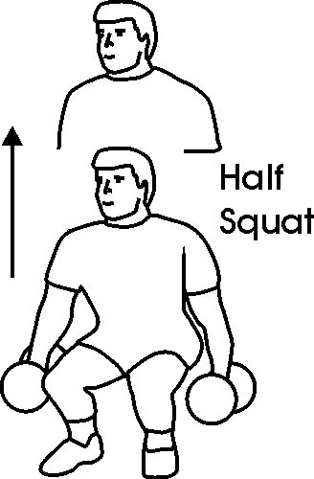 | Up down  Upper body slightly incline 45  No upper body movement  Straight feet & knee  No extra weight |  | 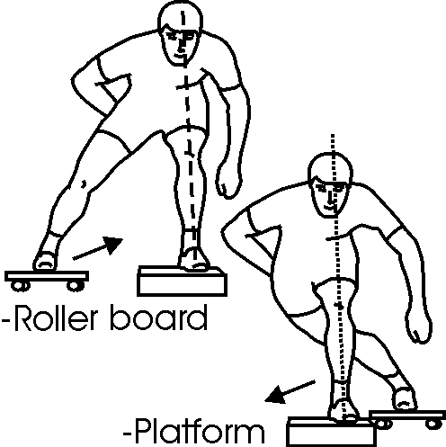 | Side to Side Jump + x over:  Always on 1 leg  Knees together  Falling on the side + push/jump  Reception on 1 leg & Xover with free leg

Mengyao Qi & Eric Bedard

