2018 Interior-Okanagan Short Track FUNale
February 10 2018
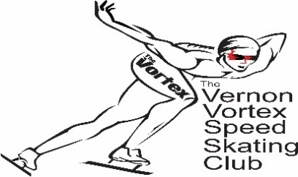
DATE: Saturday February 10 2018 LOCATION: KAL TIRE PLACE
TIME: 9am-4pm 3445 43rd Avenue
TRACK: 111m OVAL and 100m OVAL MEET TYPE: Ability, all ages
ELIGIBILITY: All BCSSA registered skaters FIRST AID: St. John’s Ambulance

SKATER NAME ________________________________________ CLUB _____________________________________________

SSC RACING #________________ BIRTH DATE ________ ________ ________ day month year

PREVIOUS BEST TIME Date: _________________ Location: ____________________________

100M track (AS/FUNd/Special Olympics/L2T/T2T) 100M__________ 200M____________ 400M______________

111.12M track (T2T/Junior and older) 500M__________ 1000M____________1500M____________

NEW SKATERS MAY HAVE COACH SUBMIT TIMES

WAIVER: By signing this entry form, I hereby, for myself, my heirs, executors, administrators and assigns, waive and release any and all rights and claims for damages I may have to Kal Tire Place, SSC and BCSSA, the Vernon Vortex Speed Skating Club and all sponsors concerned, their agents, Officers or members, for any and all injuries suffered by me at said contest to be held February 10, 2018 at The Kal Tire Place Arena in Vernon, British Columbia, Canada.
This information is collected under the authority of the Freedom of Information and Protection of Privacy Act. It is required to register you in the competition. Financial information will be used to process payment. Organization of competitions/events requires that names will appear on posted race lists and result print outs. Names/Images of participants may be published on boards, websites, media, newsletters and promotional material. Alternative contact and medical information will only be used in a medical emergency. If you have questions about the collection of or use of this information, contact vernonvortex@gmail.com.
US skaters must provide proof of current membership in the form of a letter from the State Association or an identity card and will need to be shown at registration. US skaters are NOT covered by BCSSA or SSC insurance and must carry their own insurance. In Witness whereof, I have hereunto set my hand and seal;

THIS_______ DAY OF ________________, 2018 PARENT'S SIGNATURE: ________________________________
(If skater is under legal age)

I have read and agree to the BCSSA Concussion Protocol: SKATER’S SIGNATURE: _______________________________________
PARENT'S SIGNATURE: ________________________________

(If skater is under legal age)

ENTRY CLOSING DATE: 7:00PM, Thursday February 1st, 2018
E-mail list of registrants to: vernonvortex@gmail.com

ENTRY FEE: $20 Active Start; $45.00 all other age categories (Includes $2.00 for Officials Development)

Late Entries may be subject to additional charge and fees are due prior to the skaters going on the ice.
Please bring all meet entry forms together at registration with one club cheque, Thanks!

