2018 Interior-Okanagan Short Track FUNale
February 10 2018
BIG Chill Challenge 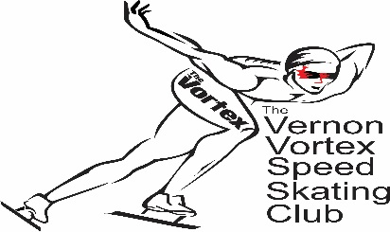

Please read all of the information

Location: Kal Tire Place, 3445 43rd Avenue Vernon BC
Time: 8am-4pm
Sanction: BCSSA Regional Sanction Competition
Medical: St. John’s Ambulance, Protocol for Speed Skating Events in BC

Meet Entries: Deadline for List of registrants must be sent to vernonvortex@gmail.com by 7:00pm Thursday February 1st, 2018. Late entries may be subject to additional charge.

Entry Fee: Active Start: $20; All other Age Categories: $45 (Includes $2 for ODC)

Format: Short Track FUNale Format

Eligible Skaters: All SSC registered skaters
Masters may skate in their own division
Active Start will skate throughout the competition, with earlier finish as they will skate fewer races than the older competitors.

Seed Time: L2T - 200M or 400M
T2T – 400M
Juniors and Seniors – 500M and 1500M
Masters – 500M
Active Start – 100M

Registration: 8:00 am Sat, February 10, 2018 @ the arena. For ease of registration/bookkeeping we request that we receive one cheque from each club.

Skater Equipment: All skaters are required to wear equipment as outlined by SSC Procedures and Regulations D3-100, D3-200, D3-300.

Skaters must wear cut resistant tubes for all competitions/meets and training sessions when NO cut resistant suit is worn. These tubes shall be made of either:
A: Kevlar B: Dyneema
All skaters are required to wear shatter resistant protective sport glasses (clear or yellow are recommended) or a complete visor. Glasses must be held in place by an elastic strap.

Skater Helmets must conform to SSC Rule D-3 “NO Bicycle helmets are allowed”. Helmets must be CSA approved and must be securely fastened under the chin.

Officials: PLEASE INCLUDE A LIST OF ANYONE INTERESTED IN OFFICIATING
– We require officials in all positions.
Contact Trevor Rasmussen @ 778-212-1488, or Eric Miller @ 250-558-9131.

Reminder:
All on-ice officials must wear safety headgear that conforms to SSC Rule D-4 for Short Track officials. Headgear must have seal of certification meeting the actual ASTM F 1849 standards. Safety headgear must be fastened securely under the chin.

We will be using helmet covers.

Tentative Schedule: Registration: 8:00am
Coaches/Officials Meeting: 9:00 am
General Warm-ups: 9:15 am
Racing: 10:00-4:00pm

For More Information, please contact:

Meet Coordinator: Trevor Rasmussen & Eric Miller
778 212 1488 250 558 9131

WE LOOK FORWARD TO SEEING YOU HERE

