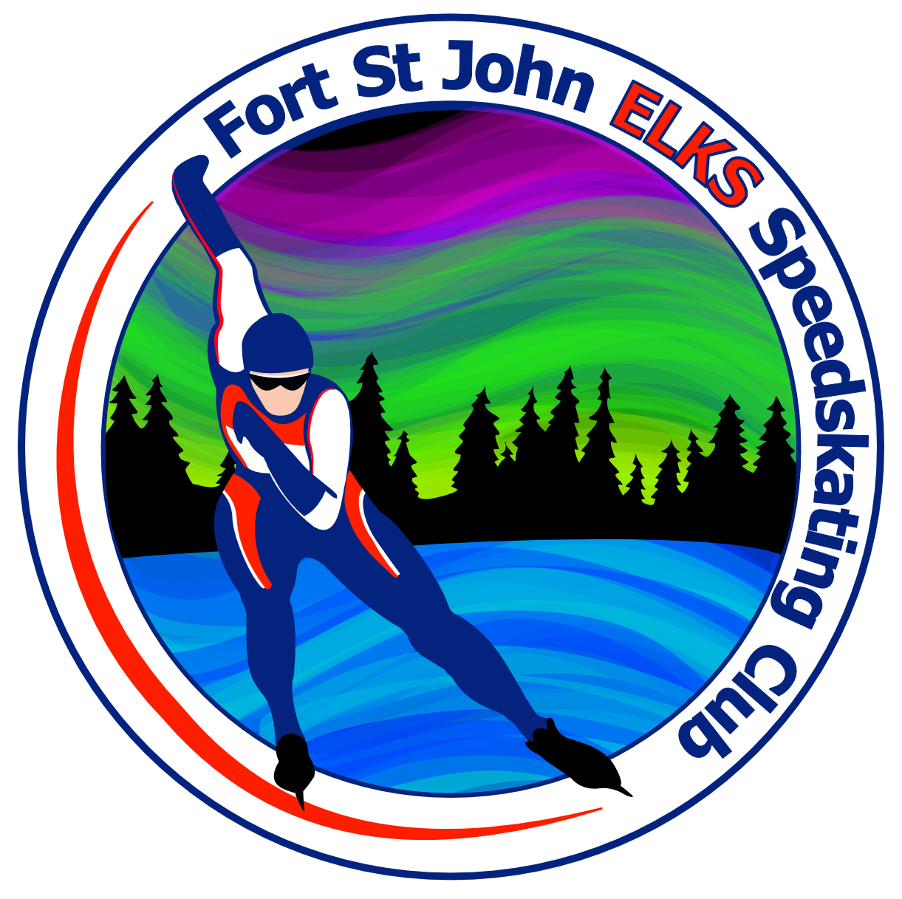
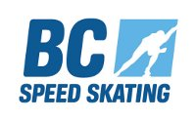
2020 BC Long Track Championships
and Long Track FUNale

Host Community Ft. St. John
MEET ENTRY FORM

SKATER NAME: _______________________________________CLUB: ____________________________

SSC RACING #:_________________________ M_____ F______

BIRTH DATE: _________ _________ _______ AGE on June 30, 2019: _______ Category __________
day month year

Previous best times:
BCLT: L2T and T2T skaters must have a 200m time less than 28.0 seconds (LT or ST) to attend BCLT. Times may be from indoor or outdoor oval, from current or last skating season, skated in a sanctioned competition.

FUNale 200m ST __________ L2T 200m ST _______ T2T 200m ST _______

200m LT __________ 200m LT _______ 200m LT _______

300m LT _______ 300m LT _______

C4L 500m LT ___________ Jr/Sr 500m LT _______

Number of banquet tickets: Adult (11 and up) ($25) _________ Children (6-10) ($10)___________
Children (5 & under) (free)_________

WAIVER: By signing this entry form, I hereby, for myself, my heirs, executors, administrators and assigns, waive and release any and all rights and claims for damages I may have against SSC and BCSSA, the Ft. St. John Recreational and Speed Skating Club, and all sponsors concerned, their agents, officers or members, for any and all injuries suffered by me at said contest to be held Jan. 25-26th, 2019 at the Pomeroy Centre, Ft. St. John, British Columbia, Canada. This information is collected under the authority of the Freedom of Information and Protection of Privacy Act. It is required to register you in the competition. Financial information will be used to process payment. Organization of competitions/events requires that names will appear on posted race lists and result lists. Names/Images of participants may be published on boards, websites, media, newsletters and promotional material. Alternative contact and medical information will only be used in a medical emergency. If you have questions about the collection of or use of this information, contact the Competition/Event Organizer Katharine North at pkgirlkate@gmail.com

I have read and agree with the BCSSA Concussion Protocol. The BCSSA Concussion Protocol can be found at: http://www.speed-skating.bc.ca/about/safety/

In Witness whereof, I have hereunto set my hand and seal; THIS____DAY OF ________, 201_

SKATER'S SIGNATURE: _______________________________________

PARENT'S SIGNATURE: _____________________________________(if skater under 18 years of age)

